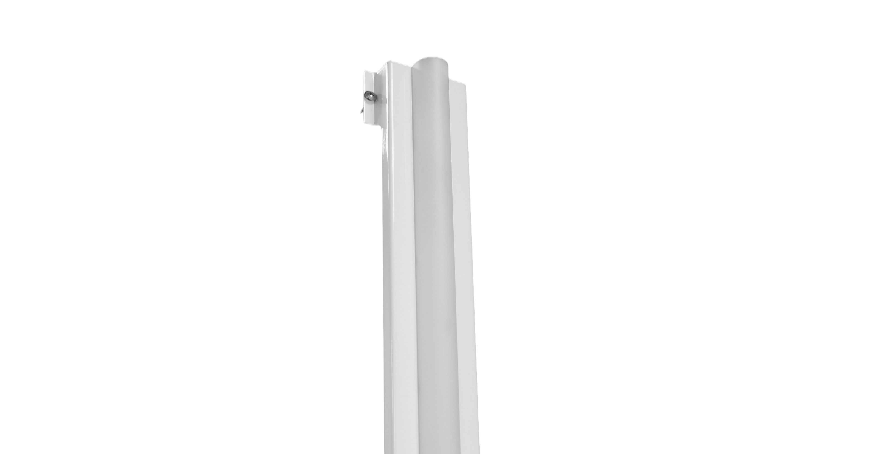
VULKAAN Retro-fit LED Gear Tray

Product Description
The VULKAAN is an LED retrofit and universal gear tray that is designed to replace two fluorescent tubes in most watertight luminaires in a marine environment. It boasts a unique and rapid fixing system, which is tested and proven to withstand the full rigor of a marine environment, including the full range of vibrations that a ship experiences from the deck to the bow thruster room. The VULKAAN typically produces slightly more light than the existing fluorescent tubes but uses 75% less energy. The diffuser is specially designed to create light spread most similar to fluorescent tubes, with over 30% emitting sideways. The fixings are designed to fix to the existing tray and yet allow access to release the existing tray for future access. The steel frame performs as a heat sink for the LED whilst also giving it rigidity and structure to maximize life expectancy, holding the light output at an incredibly high level over its expected life at 24/7 use.
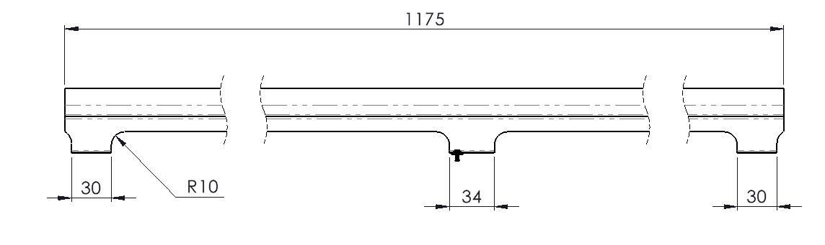

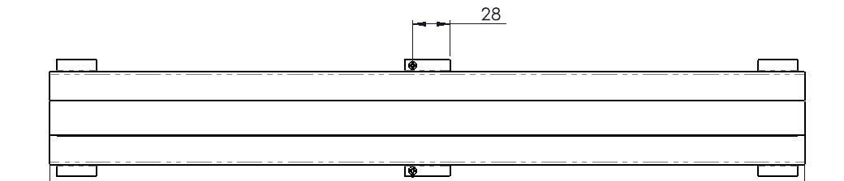

Specification
VULKAAN | LED Retrofit Gear Tray
Wattage (WW) – std | 11W (11) | 22W (22)
Wattage (WW) – cornice | 5.5W (5.5) | 11W (11)
Voltage/Hz | 220-240V, 50/60Hz
Lumens/W | 154lm/w
Light Colour (YY) | 3,000K (30), 4,000K (40), 5,000K (50), 6,500K (65)
CR Index | CRI 80+
Protection Class | Installed inside existing marine luminaire
Dimensions (mm) | 575 x 88 x 52 | 1175 x 88 x 52
Fixing/Mounting | Self-drilling tech screws c/w vibration resistant washer
Construction/Finish | White powder coated steel
Operating Temperature (ta) | -20ᵒC - +60ᵒC. tc 75ᵒC; tp 50ᵒC.
Warranty | 5 years
Lumen Maintenance L70B50 | 72,000hrs; Driver = 100,000hrs
Product Code (std) | TGTWWYY | TGTWWYY
Product Code (cornice) | TGTCWWYY | TGTCWWYY

Add Suffix: ‘E’ for Emergency or ‘E24’ for Emergency 24V

